PPspliT for macOS

S

ince the time Office 2016 has superseded *Office for Mac 2011*, the features of PowerPoint for Windows and for macOS have been largely equalized. Even the VBA programming interface, which was previously rather limited on macOS, started to match so closely that the code base of PPspliT became seamlessly portable between PowerPoint for Windows and PowerPoint for macOS, thus opening an opportunity to extend development to this platform.

As of today, the user experience of PPspliT is largely unchanged between Windows and macOS. However, security features of macOS may require a few easy tricks at the setup stage to ensure a minimal set of authorizations required to enable the add‑in are granted. These tricks, as well as intructions for uninstalling PPspliT on macOS, are detailed below.

# Installation instructions

PPspliT for macOS is made conveniently available in the form of a .dmg image file with an embedded installer app. Installing software packaged in this file format is straightforward in macOS, yet security restrictions introduced in releases starting from Catalina require explicit authorizations from the user at the setup stage. These authorizations are needed to let the installer perform 2 non‑intrusive actions on your system: 1) copying a file to a path in the user’s home directory and 2) activating the add‑in inside PowerPoint.

Granting the required authorizations can be accomplished as follows[1].

1. Download PPspliT.dmg from my web site.
2. Double click on the PPspliT.dmg file to open it in the Finder. A window should pop up containing the Install PPspliT.app application bundle.
3. Double click on Install PPspliT.app to start the PPspliT installer. At this point a security prompt may warn you about the fact that the installer has not been signed, preventing it from continuing the setup process. You can safely dismiss this prompt by clicking on the button that does *not* trigger any further actions. This button may vary depending on the release of macOS:

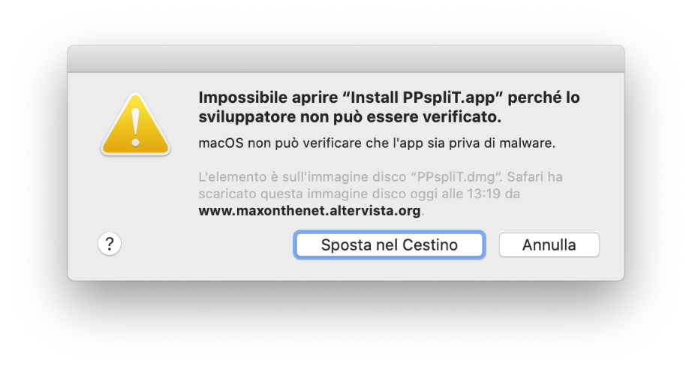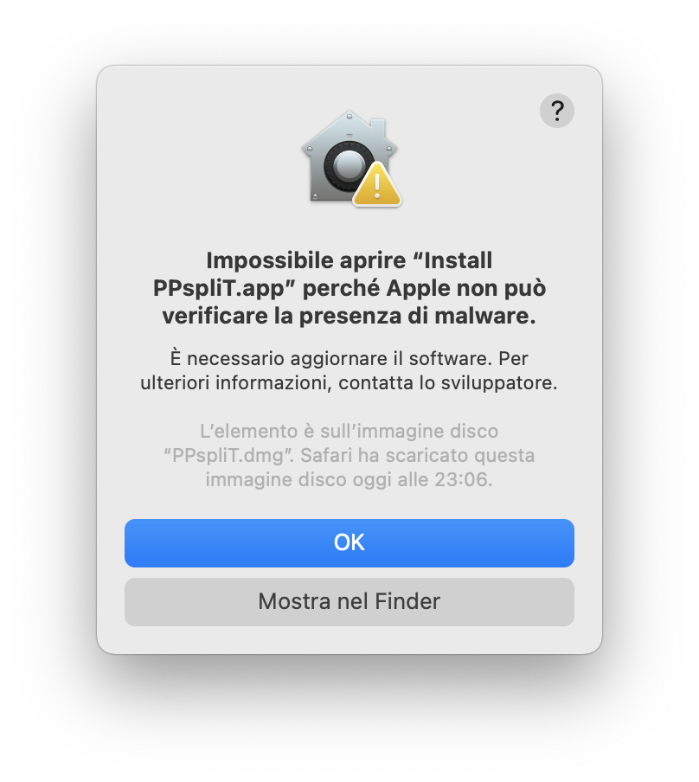

1. Open macOS’s “*System Settings*” (named “*System Preferences*” in releases earlier than Ventura) and access the “*Privacy and Security*” (or “*Security and Privacy*”) panel. Depending on the macOS release, the panel may be found in different places:

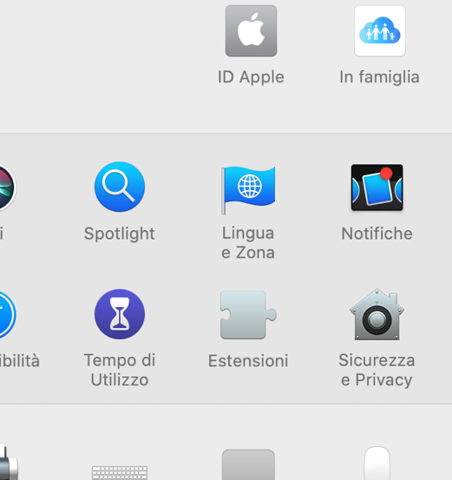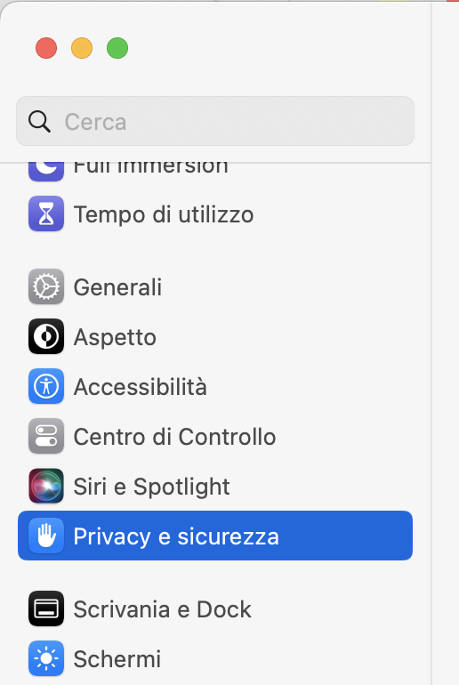

1. Two actions need to be performed in this panel: 1) enabling app installation from other sources besides the App Store and 2) confirming the intention to open the Install PPspliT.app application. Once more, the exact procedure depends on the release of macOS.   
   Starting from macOS Ventura, scroll all the way down in the opened panel, make sure that the “*Allow apps downloaded from*” selector is set to “*App Store and identified developers*”, look for a warning about the Install PPspliT.app application and click on “*Open anyway*”:

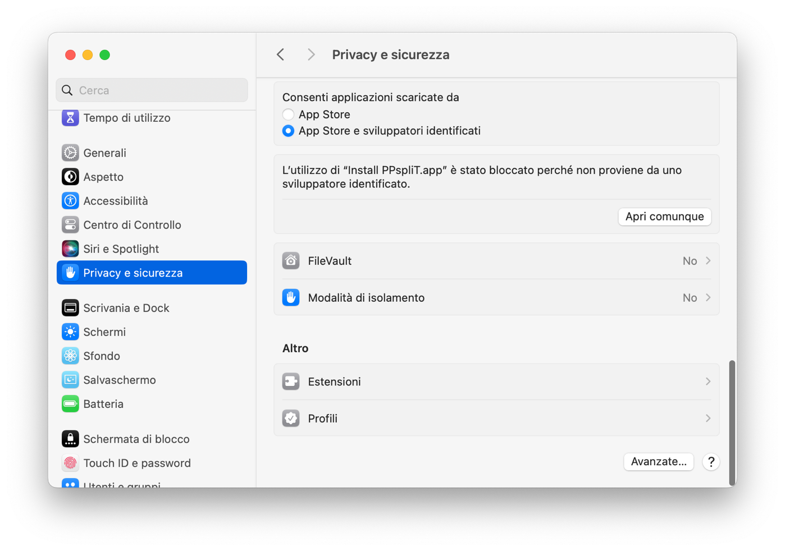

In earlier releases of macOS the same function is found in the “*General*” tab: make sure that the “*Allow apps downloaded from*” selector is set to “*Anywhere*” or, in case this is unavailable, to “*App Store and identified developers*”, then just click on “*Open anyway*”:

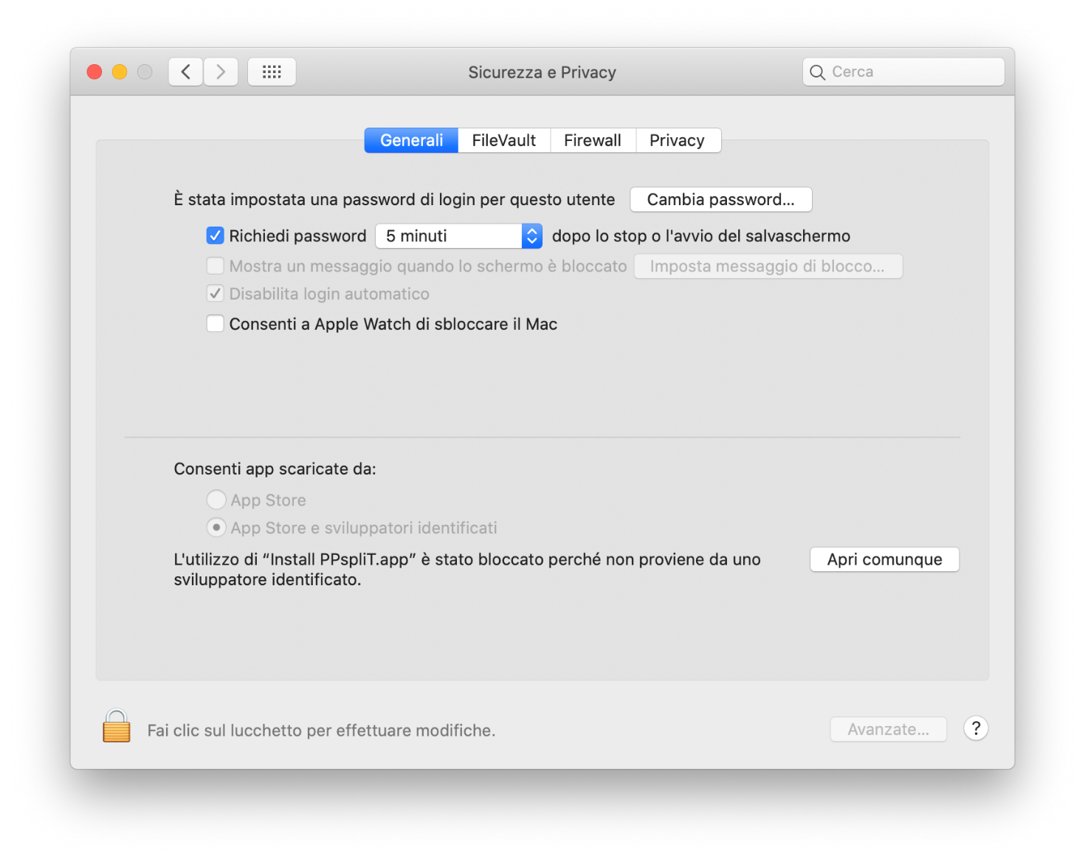

1. Immagine che contiene screenshot

   Descrizione generata automaticamenteAt this point the installer should successfully start:
2. As indicated in the above message, further security restrictions require accepting a few security prompts that may come out during the installation process. For example (the actual message and dialog box may change depending on the release of macOS):   
     
   Please safely accept all these security prompts, as the installer would not be able to proceed otherwise.

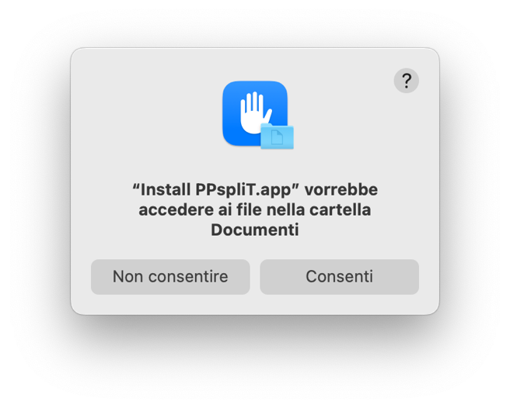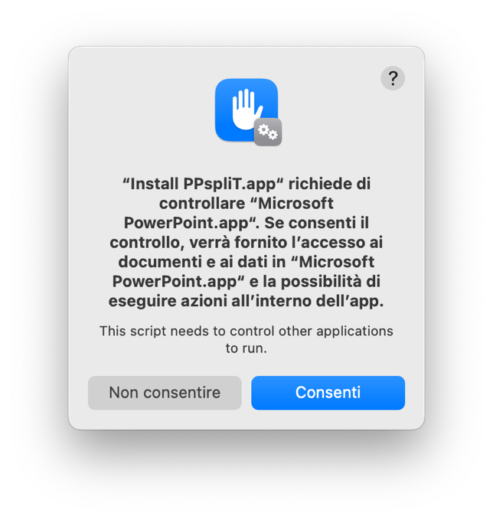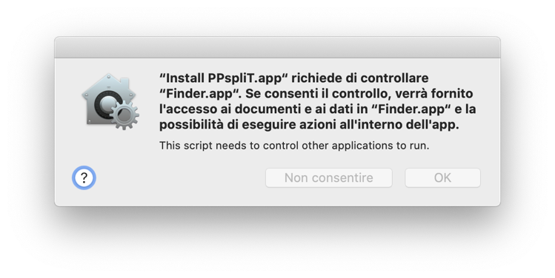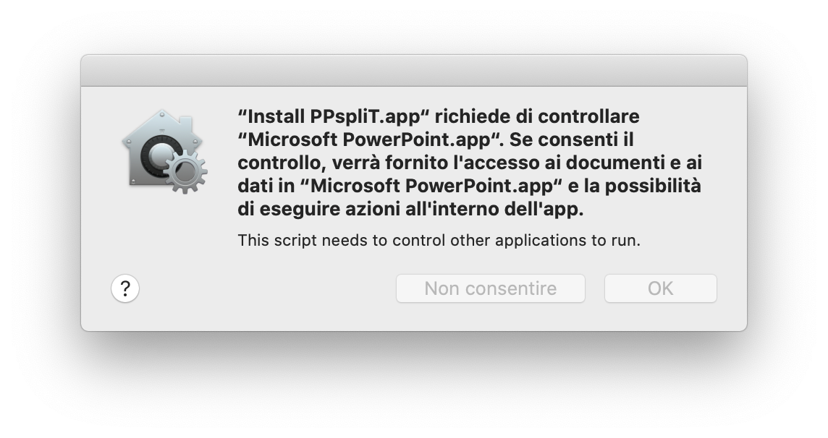

1. Immagine che contiene screenshot

   Descrizione generata automaticamenteImmagine che contiene screenshot

   Descrizione generata automaticamenteThe following window confirms that the installation has been successfully completed:
2. As a result, the PPspliT toolbar should be immediately available in PowerPoint:   
     
   Please notice that the add‑in does not provide any entries in the macOS top menu bar: just a tab in the ribbon. Especially if you have many tabs displayed and the PowerPoint window is not large enough, you may need to click on the double arrow at the right of the ribbon tab bar to reveal the PPspliT entry (see the above picture).

# Uninstallation instructions

The PPspliT installer makes use of the AppleScript automation facility. Unfortunately, while an interface is exposed by PowerPoint to register new add‑ins through AppleScript, the same does not apply for de‑registration. Therefore, uninstallation of PPspliT on macOS must be performed manually.

The process is fairly simple:

1. 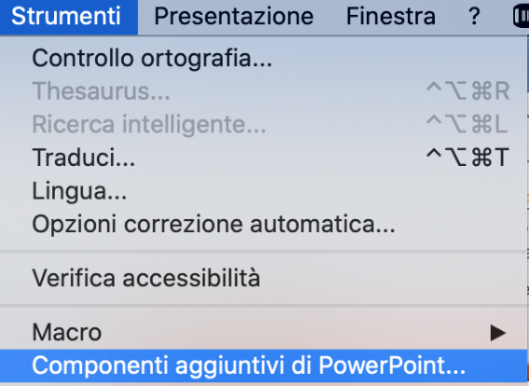Start PowerPoint and, from the top menu, select “Tools”à”Add‑Ins…”:
2. 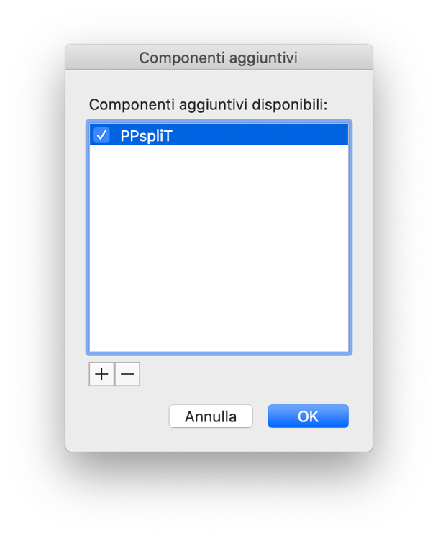Select “PPspliT” in the list and click on the minus “–“ button below:
3. Open the *Terminal* application of macOS and type the following command:   
     
   rm ~/Library/Group\ Containers/UBF8T346G9.Office/PPspliT.ppam   
     
   That’s it.

1. For more information, see also <https://support.apple.com/en-us/102445>.